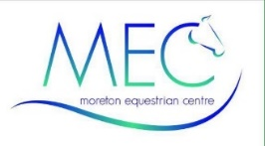
DANNIE MORGAN
BD GRAND PRIX DRESSAGE RIDER & TRAINER
DRESSAGE CLINICS

Wednesday 29th April 2026
Wednesday 6th May 2026
Monday 8th June 2026
Wednesday 24th June 2026
Wednesday 15th July 2026
Wednesday 29th July 2026
Wednesday 19th August 2026

Dannie Morgan has a prolific record with BD, riding numerous horses. He has won 23 National Titles and over 50 Regional Titles. He is an approachable and knowledgeable trainer who improves both the way of going and arena craft for those willing to learn.

A 45 mins individual session will be £80 (£10 payable on MRL for arena Hire and £70 payable to Dannie on the day).

Refunds will only be given provided your place can be filled.

Applications to be received 5 days before each clinic. The clinic will take place in the 80m x 65m Fibretrack arena.

Times will available by telephoning/texting 07780 694 535, 3 days prior to the clinic.

